

Online Grocery Store
15/04/2024
Pankaj Kumar
12209716
SECTION K22Ae

Prepared for
Continuous Assessment 3
Spring 2024

Table of Contents

1. Introduction
1.1 Purpose
1.2 Scope
1.3 Overview
2. General Description
2.1 Product Perspective
2.2 Product Functions
2.3 User Characteristics
2.4 General Constraints
2.5 Assumptions and Dependencies
3. Specific Requirements
3.1 External Interface Requirements
3.1.1 User Interfaces
3.1.2 Hardware Interfaces
3.1.3 Software Interfaces
3.1.4 Communications Interfaces
3.2 Functional Requirements
3.2.1 User Registration
3.2.2 Product Search and Ordering
3.3 Non-Functional Requirements
3.3.1 Performance
3.3.2 Reliability
3.3.3 Availability
3.3.4 Security
3.3.5 Maintainability
3.3.6 Portability
4. DATA FLOW DIAGRAMS
4.1 Zero Level
4.2 FIRST LEVEL
4.3SECOND LEVEL
5. Github link…………………………………………………………………………………………………….
A. Appendices
A.1 Appendix 1 SCREENSHOT OF WEBSITE

1. INTRODUCTION

1.1 PURPOSE

The purpose of this document is to outline the requirements for the development of an online grocery store. It details the functionality, constraints, and interfaces of the system to be developed.

1.2 SCOPE

The scope of this project includes the development of an online platform where users can browse, search for, and purchase groceries. It also includes administrative functionalities for managing products, orders, and user accounts.

1.3 OVERVIEW

This document provides an overview of the general and specific requirements for the online grocery store system. It outlines the functionalities, interfaces, and constraints of the system to be developed.

2. GENERAL DESCRIPTION

2.1 PRODUCT PERSPECTIVE

The online grocery store system will function as a standalone application, interacting with users through a web interface. It may integrate with external payment gateways and inventory management systems.

2.2 PRODUCT FUNCTIONS

- User registration and authentication

- Product browsing, searching, and ordering

- Cart management

- Payment processing

- Order tracking

2.3 USER CHARACTERISTICS

The system will be designed to accommodate users with varying levels of technological proficiency. Users should be able to navigate the platform easily to search for and purchase groceries.

2.4 GENERAL CONSTRAINTS

- Compliance with data protection regulations

- Compatibility with common web browsers and devices

- Scalability to handle increasing numbers of users and products

2.5 ASSUMPTIONS AND DEPENDENCIES

- Availability of stable internet connection for users

- Availability of necessary hardware and software resources for system deployment

3. SPECIFIC REQUIREMENTS

3.1 EXTERNAL INTERFACE REQUIREMENTS

3.1.1 User Interfaces

The user interface shall be web-based and intuitive, allowing users to easily navigate through product categories, search for specific items, and complete purchases.

3.1.2 Hardware Interfaces

The system shall be compatible with commonly used web browsers and devices, including desktops, laptops, tablets, and smartphones.

3.1.3 Software Interfaces

The system may integrate with external payment gateways for processing transactions and with inventory management systems for updating product availability.

3.1.4 Communications Interfaces

The system shall communicate with users through email notifications for order confirmations, shipment updates, and promotional offers.

3.2 FUNCTIONAL REQUIREMENTS

3.2.1 User Registration

- Users shall be able to create accounts by providing necessary information such as name, email, and password.

- Accounts shall be verified via email for security purposes.

3.2.2 Product Search and Ordering

- Users shall be able to search for products by category, keywords, or brand.

- Users shall be able to add products to their cart and proceed to checkout for payment.

3.3 NON-FUNCTIONAL REQUIREMENTS

3.3.1 Performance

The system shall be responsive and capable of handling concurrent user sessions without significant slowdown.

3.3.2 Reliability

The system shall minimize downtime and errors, ensuring a reliable shopping experience for users.

3.3.3 Availability

The system shall be available 24/7, with scheduled maintenance communicated to users in advance.

3.3.4 Security

The system shall implement security measures such as encryption, secure authentication, and protection against common web vulnerabilities.

3.3.5 Maintainability

The system shall be designed with modular components and well-documented code to facilitate future updates and maintenance.

3.3.6 Portability

The system shall be deployable on various hosting platforms and easily adaptable to different environments.

4. DATA FLOW DIAGRAMS(DFD)

4.1 ZERO LEVEL

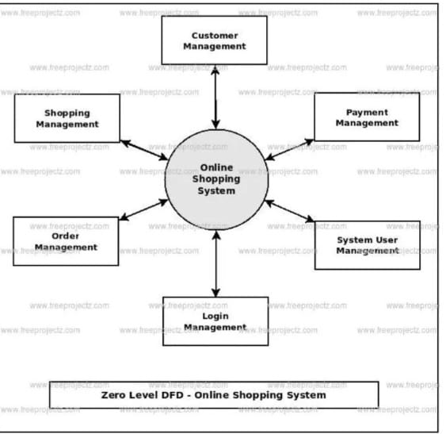

4.2 FIRST LEVEL

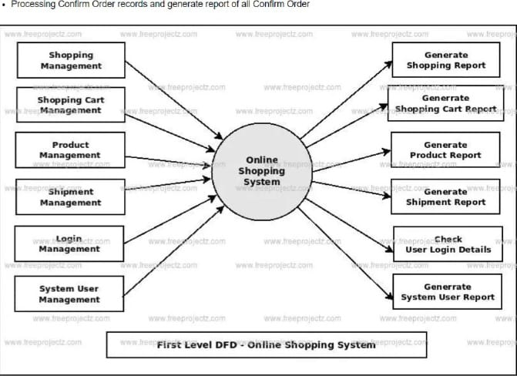

4.3 SECOND LEVEL

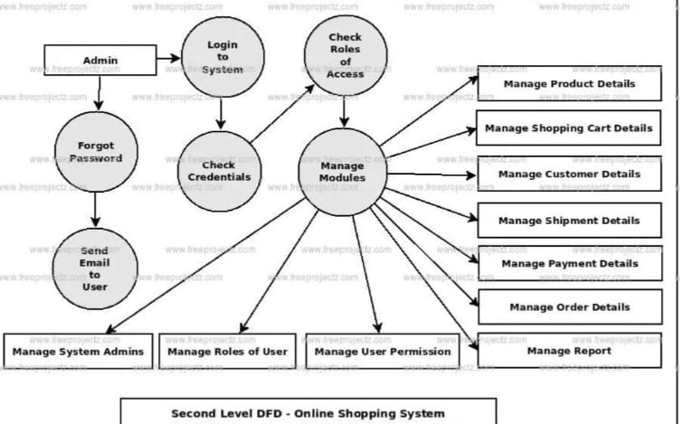

5. GitHub Link

https://github.com/salaria07/Online-Grocery-Store

A.APPENDICS

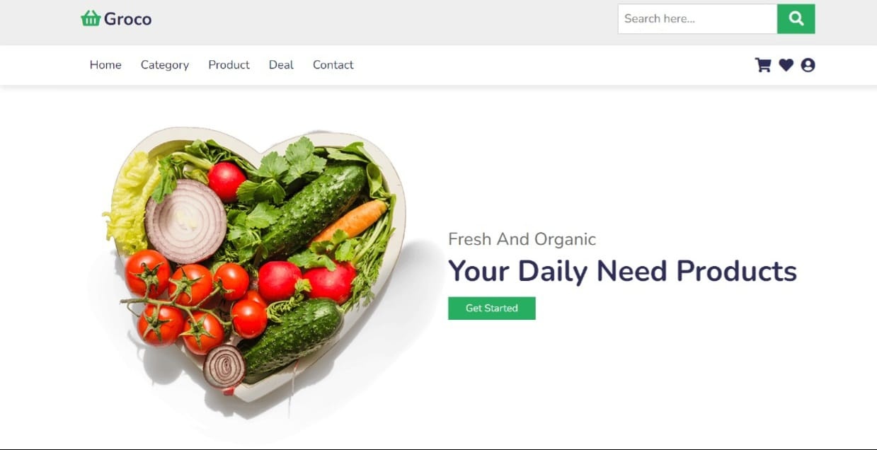

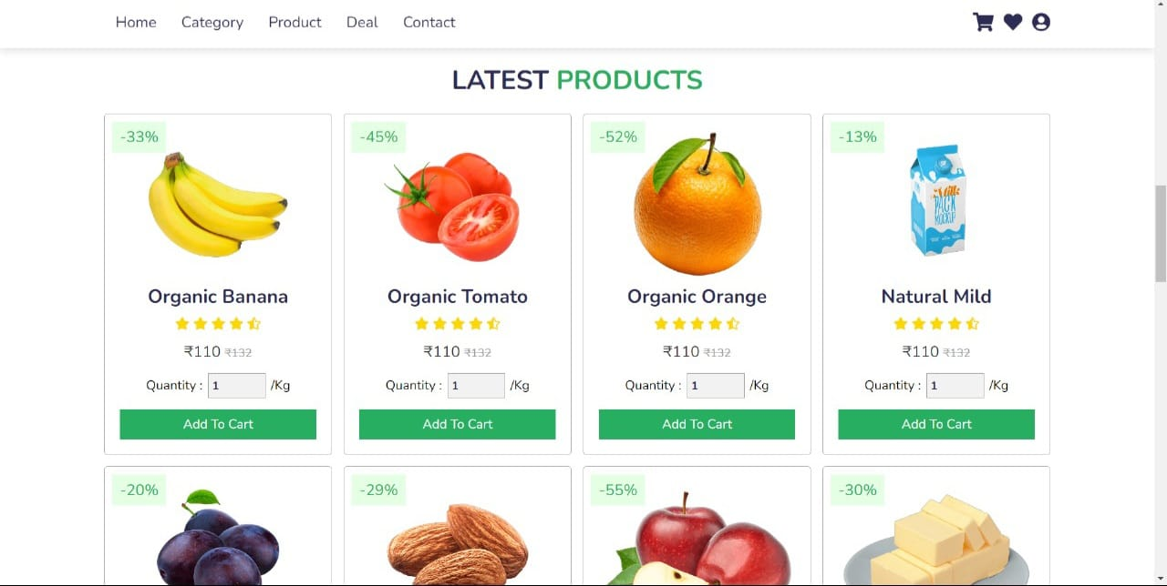

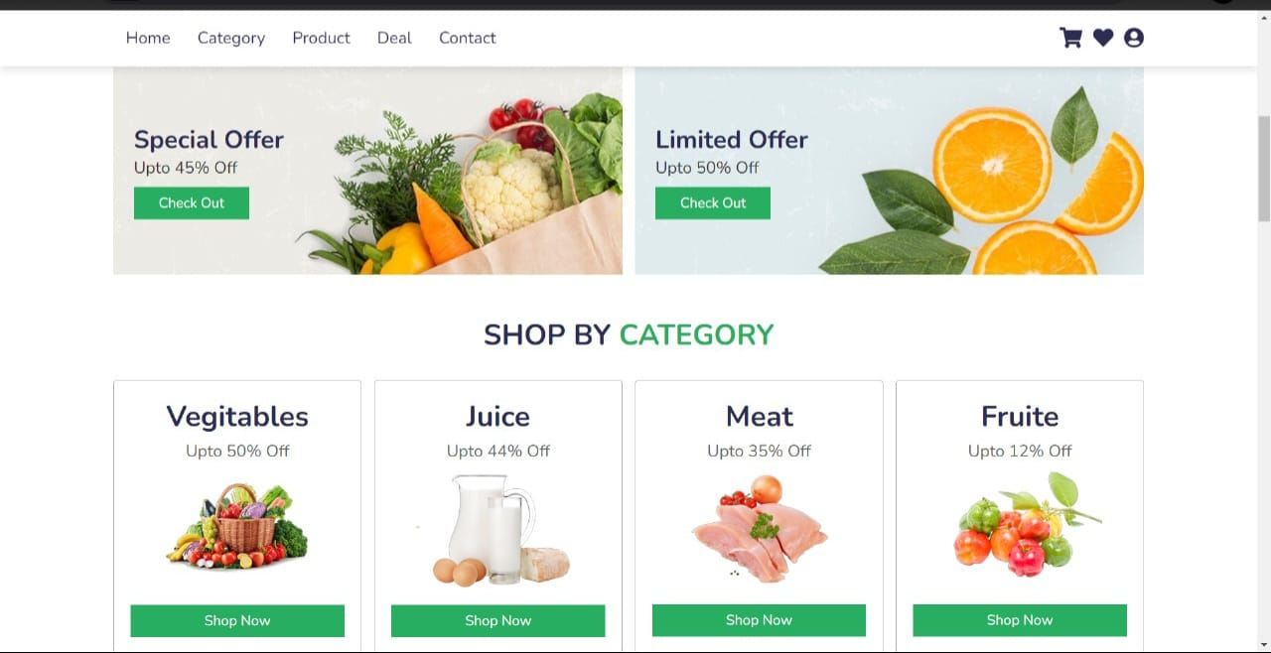

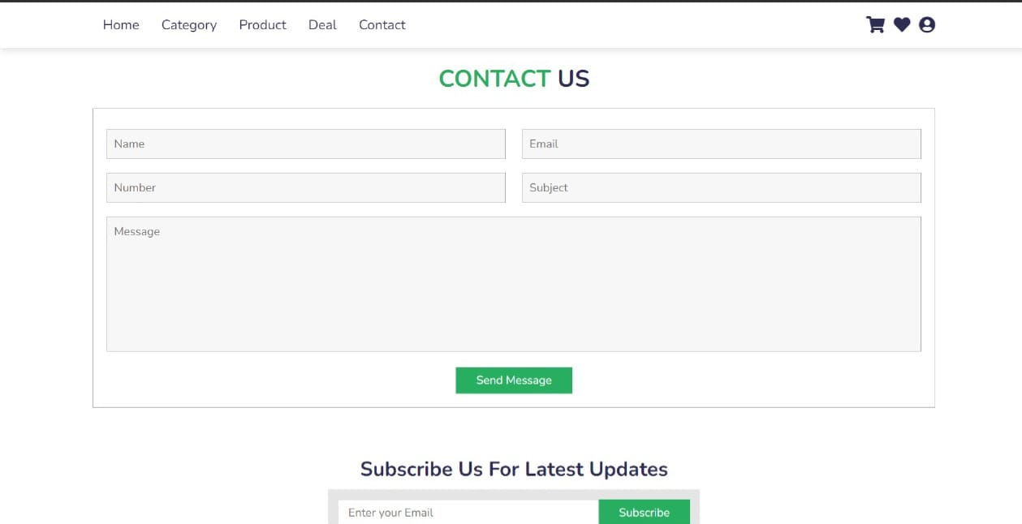

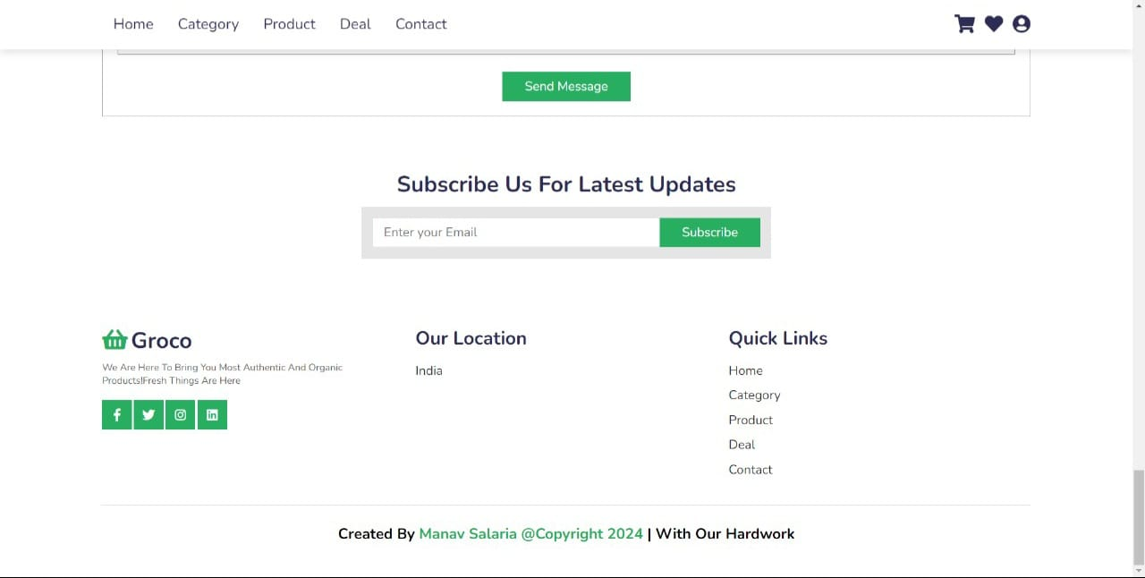

6.CODE SNIPPETS

